2023 Week of Prayer for Christian Unity

Do good; seek justice (Isaiah 1:17)
The 2023 WPCU international and Canadian resources are available to download at: weekofprayer.ca/2023-wpcu-resources (English)
semainedepriere.ca/fr/ressources-pour-la-spuc-2023 (French)

We encourage you to be creative in your use of the Week of Prayer for Christian Unity resources! While the WPCU is normally celebrated in January each year (January 18-25 in the northern hemisphere), you may choose instead to have an event at another time that makes sense for your campus, or a series of events spread throughout the school year. This year’s worship and Bible study materials focus on social justice and storytelling, and they may pair well with other events that your campus may host related to peace, justice, and reconciliation.

Ecumenical WORSHIP SERVICE

Instructions for those preparing the worship

The river/water motif has strong cultural relevance for the local committee designing these worship resources. For the Minnesotan context the river and water have meant both cultural genesis and genocide at points in the history of this region.

This motif also has theological and liturgical significance. The Week of Prayer for Christian Unity (WPCU) in the Northern Hemisphere is observed in January, not long after many traditions commemorate the Baptism of the Lord. This belief that all belong and are members of this beloved community that both is and is becoming, fuels the work of social justice, and racial justice in particular, calling us to public witness and advocacy as co-creators with God in bringing into existence peace with justice in all creation.

In other parts of the world, the WPCU is observed around Pentecost, when we celebrate the genesis of the Church and we are built up in the Body of Christ as living stones. The Church is instituted by the Spirit in the midst of diversity and with the unifying and prophesying power of the Holy Spirit. Unity in the midst of diversity and this unifying and prophesying power fuels the work of justice, making plain our common humanity and giving us the ability to communicate, despite differences, as well as the ability to bear witness to and through the power of God.

The connection between stone and water in the Native Minnesota context is about understanding the value and importance of life. In most Native American wisdom, water and stone occupy sacred positions. Water is life and stones represent the sacredness of the ground upon which many generations have stood. All of creation is endowed with the Spirit of God, therefore we are all related. Two symbols will be used in the worship service: water, representing our baptism into new life, and stone, representing our personal and ancestral history.

After greeting the assembly, we pause for a moment of confession and forgiveness which incorporates the principal text for the Week of Prayer (Isaiah 1:12-18). During the ritual action, as part of the penitential act, the presider pours a pitcher of water into the baptismal font (or a basin) during the reading of verses 16 and 17. It is important that this is done slowly and audibly so the congregation may meditate on the meaning of what is being said and what is being symbolically recalled. After the act of confession and pardon, there follows an opening prayer, hymn and liturgy of the Word.

Grounded in the text from Isaiah, the homily or sermon needs to link the issues of Christian unity and racial injustice which is both individual and systemic or institutional. The marginalization of people because of their “race”, culture or language tears apart the fabric of the human community and is the cause of disunity in our Christian community. Christian unity needs to be strong and visible so as to speak to how the same Spirit received in our baptism creates unity out of the rich diversity of God’s creation and is the plan of God for the unity of humanity.

The homily should also lead into the symbolic act which follows. All present should be given a stone as they arrive. The communities that plan the worship together could identify and invite two or three persons to tell stories about racial injustice and about how Christian unity can serve the overcoming of injustice. After each story, the speaker places his or her stone around a cross or lit candle, the symbol of Christ the corner stone. This ritual action should be planned to be about 15 minutes in duration. At the conclusion of this symbolic act, the presider can invite the congregation to continue the telling of their stories after the worship.

The liturgy concludes with the prayers of the people, the praying together of the Lord’s Prayer, the benediction and dismissal. There are indications for music at different points of the service and some suggested texts or hymns are found in the Appendix.

This ecumenical worship service has a simple order that can be adapted for local situations and traditions to allow for diversity of expression and expansion of the celebration to include other elements of practice, such as local rituals and prayers. Through the written words of this liturgy, it is meant to convey the emotions, struggles, and hope of the current day descendants of enslaved African American and Indigenous people residing in Minnesota. This will be accentuated in particular in the hymns and songs chosen for the worship.

Order of Worship

L Leader
R Reader
C Congregation

Prelude

Call to Gather

L Sisters and brothers, we gather here in the name of the Father, of the Son, and of the Holy Spirit.

By the waters of baptism, we have become members of the Body of Christ, yet our sins have caused pain and trauma to each other.

We have failed to do good.

We have not sought justice in the face of grave oppression, nor heeded God’s command to care for the widow and orphan (Isaiah 1:17).

As we gather, let us reflect on our actions and inactions and learn to do good and seek justice.

We need God’s grace to overcome our divisions and to uproot systems and structures that have contributed to the fracturing of our communities.

We gather to pray to reinforce the unity that we have as Christians to “open our hearts, that we may be bold in finding the riches of inclusion and the treasures of diversity among us. We pray in faith.”

Hymn

Many and great, O God (Dakota Hymn)

Words of Welcome

Invitation to Confession and Forgiveness

Confession and Forgiveness through the Reading of Isaiah 1:12-18

L We are invited to confess our sins with the words of the prophet Isaiah.

R 1 When you come to appear before me, who asked this from your hand? Trample my courts no more; bringing offerings is futile; incense is an abomination to me (12 – 13a).

C Forgive us Lord when we come to worship without walking humbly before you.

Silence

R 2 New moon and Sabbath and calling of convocation – I cannot endure solemn assemblies with iniquity. Your new moons and your appointed festivals my soul hates; they have become a burden to me, I am weary of bearing them (13b – 14).

C We ask forgiveness for the complicity of churches in the evils of colonialism felt around the world.

Silence

R 3 When you stretch out your hands, I will hide my eyes from you; even though you make many prayers, I will not listen; your hands are full of blood. (15)

C We ask forgiveness for our sins of injustice and oppression that supress the diverse harmony of your creation.

Silence

(At the font, the presider slowly pours a pitcher of water into the font or a basin during the reading.)

R 4 Wash yourselves; make yourselves clean; remove the evil of your doings from before my eyes; cease to do evil, learn to do good; seek justice, rescue the oppressed, defend the orphan, plead for the widow. (16, 17)

C As we have been washed clean in the living waters of baptism, forgive us anew and reconcile us to one another and to creation.

Silence

R 5 Come now, let us argue it out, says the Lord: though your sins are like scarlet, they shall be like snow; though they are red like crimson, they shall become like wool. (18)

L May God, in his mercy, free you from your sins so that you can do justice, love kindness and walk humbly with your God.

Silence

L Almighty God hears our prayers, has mercy on us and forgives our sins.

C Thanks be to God.

Prayer

L God of all, our hearts and bodies are thankful for this opportunity to come before you to confess our sins of injustice and divisiveness.

Together we come before you, a holy family, united in the beautiful diversity of your creation: some of us are Indigenous peoples, some of us are descendants of the enslaved, some of us are descendants of the enslavers, some of us are migrants, some of us are refugees, but all of us are part of the one Body of Christ.

We praise you that through the living waters of baptism our sins, red as scarlet, were washed away and we were healed, as we became part of the beloved community, the family of God. We offer our thanksgiving and praise to you, Creator God.

Together on this journey, we celebrate with our hearts and eyes open to understanding and growing in the sacred wisdom that is shared and passed amongst all people. Help us to embrace unity with each other, and remind us that we are of one family gathered by your Holy Spirit, in the midst of your creation. Amen

Hymn

Wade in the water

Epistle Reading Ephesians 2:13-22

Psalm 42 (responsively)

R As a deer longs for flowing streams, so my soul longs for you, O God.
My soul thirsts for God, for the living God.
When shall I come and behold the face of God?
C Hope in God; for I shall again praise him.
R My tears have been my food day and night, while people say to me continually,
“Where is your God?”
These things I remember, as I pour out my soul:
how I went with the throng, and led them in procession to the house of God,
with glad shouts and songs of thanksgiving, a multitude keeping festival.
C Hope in God; for I shall again praise him.
R Why are you cast down, O my soul, and why are you disquieted within me?
Hope in God; for I shall again praise him, my help and my God.
My soul is cast down within me;
C Hope in God; for I shall again praise him.
R By day the Lord commands his steadfast love, and at night his song is with me,
a prayer to the God of my life.
I say to God, my rock,
“Why have you forgotten me?
Why must I walk about mournfully because the enemy oppresses me?”
C Hope in God; for I shall again praise him.
R As with a deadly wound in my body, my adversaries taunt me,
while they say to me continually, “Where is your God?”
Why are you cast down, O my soul, and why are you disquieted within me?
C Hope in God; for I shall again praise him.

Gospel Reading Matthew 25:31-40

Hymn

Come thou fount of every blessing

Homily/Sermon

(Moment of silence or hymn)

Stones and Stories

The two or three identified story tellers are invited to come forward.

L Let us hear some stories. As living stones, we are bearing witness to the stories that will live on. With each story, the Body of Christ is being built up and edified. Our stories are intertwined with the story of Christ, the Corner Stone of our Christian unity. As God has created us to be in communion, so too our stories are connected. Let us reflect as we hear these stories, each holding our stone.

The story tellers give their testimonies. After each story, worshippers join in the response below:

C I commit myself to respond to the call of Isaiah to ‘do good and seek justice.’

Hymn

What a fellowship, what a joy divine

Prayers of Intercession

L With faith and confidence, we come in prayer, before God, who is Father, Son and Holy Spirit:
Creator God, today we live with the consequences of actions that have made life unsustainable for some and overabundant for others. Teach us to know how to use responsibly the resources you have given to us for the benefit of all and the respect of your creation. The groaning creation cries out to you.
C Teach us and show us the way.

L Compassionate God, help us repair the harm that we have inflicted upon each other and the divisions we have created among your people. Just as Christ Jesus breathed the Holy Spirit onto the disciples to birth the community of the new creation, send your grace to heal our divisions and gift us with the unity for which Jesus prayed.
C Teach us and show us the way.

L Christ, the way, the truth and the life, you embodied justice in your ministry on earth by the good that you did, breaking down the walls that divide and the prejudices that imprison. Open our hearts and minds to recognize that though we are many, we are one in you.
C Teach us and show us the way.

L Holy Spirit, you create anew the face of the earth. The summit of the mountains, the thunder of the sky, the rhythm of the lakes speak to us –
C Because we are connected.

L The faintness of the stars, the freshness of the morning, the dewdrops on the flower speak to us –
C Because we are connected.

L The voices of the poor, the oppressed and the marginalized speak to us –
C Because we are connected.

L But above all, our hearts soar to you for we cry out ‘Abba, Father’ as we say:

C Our Father.…

Closing Prayer

L Everlasting God, look upon these faces gathered together in holy community and send them anywhere you would have them go.

Encourage them by your Holy Spirit to continue to tell their stories, to do good, and to seek justice for the sake of your Creation through their actions.

Sustain them that they may be one, so the world may believe that you sent your only Son Jesus for the life of the world.

Sending Forth

L The Lord bless you and keep you;
The Lord make his face shine on you and be gracious to you.
The Lord lift up his countenance upon you.
And give you peace. Amen

Hymn

Lift every voice and sing

APPENDIX*

Hymn Many and great, O God (Dakota Hymn)

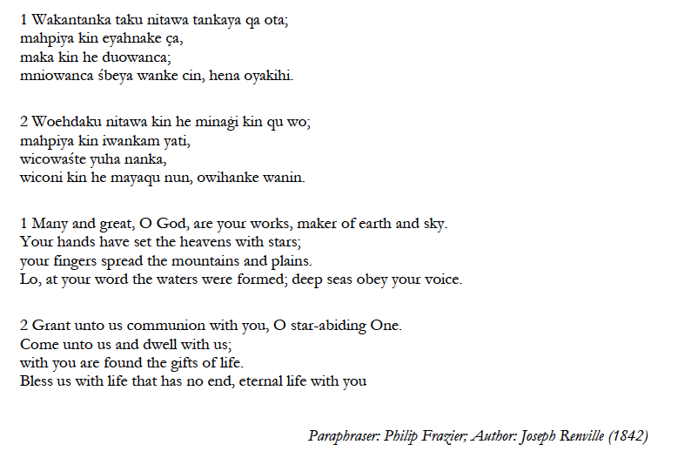

Hymn Wade in the water

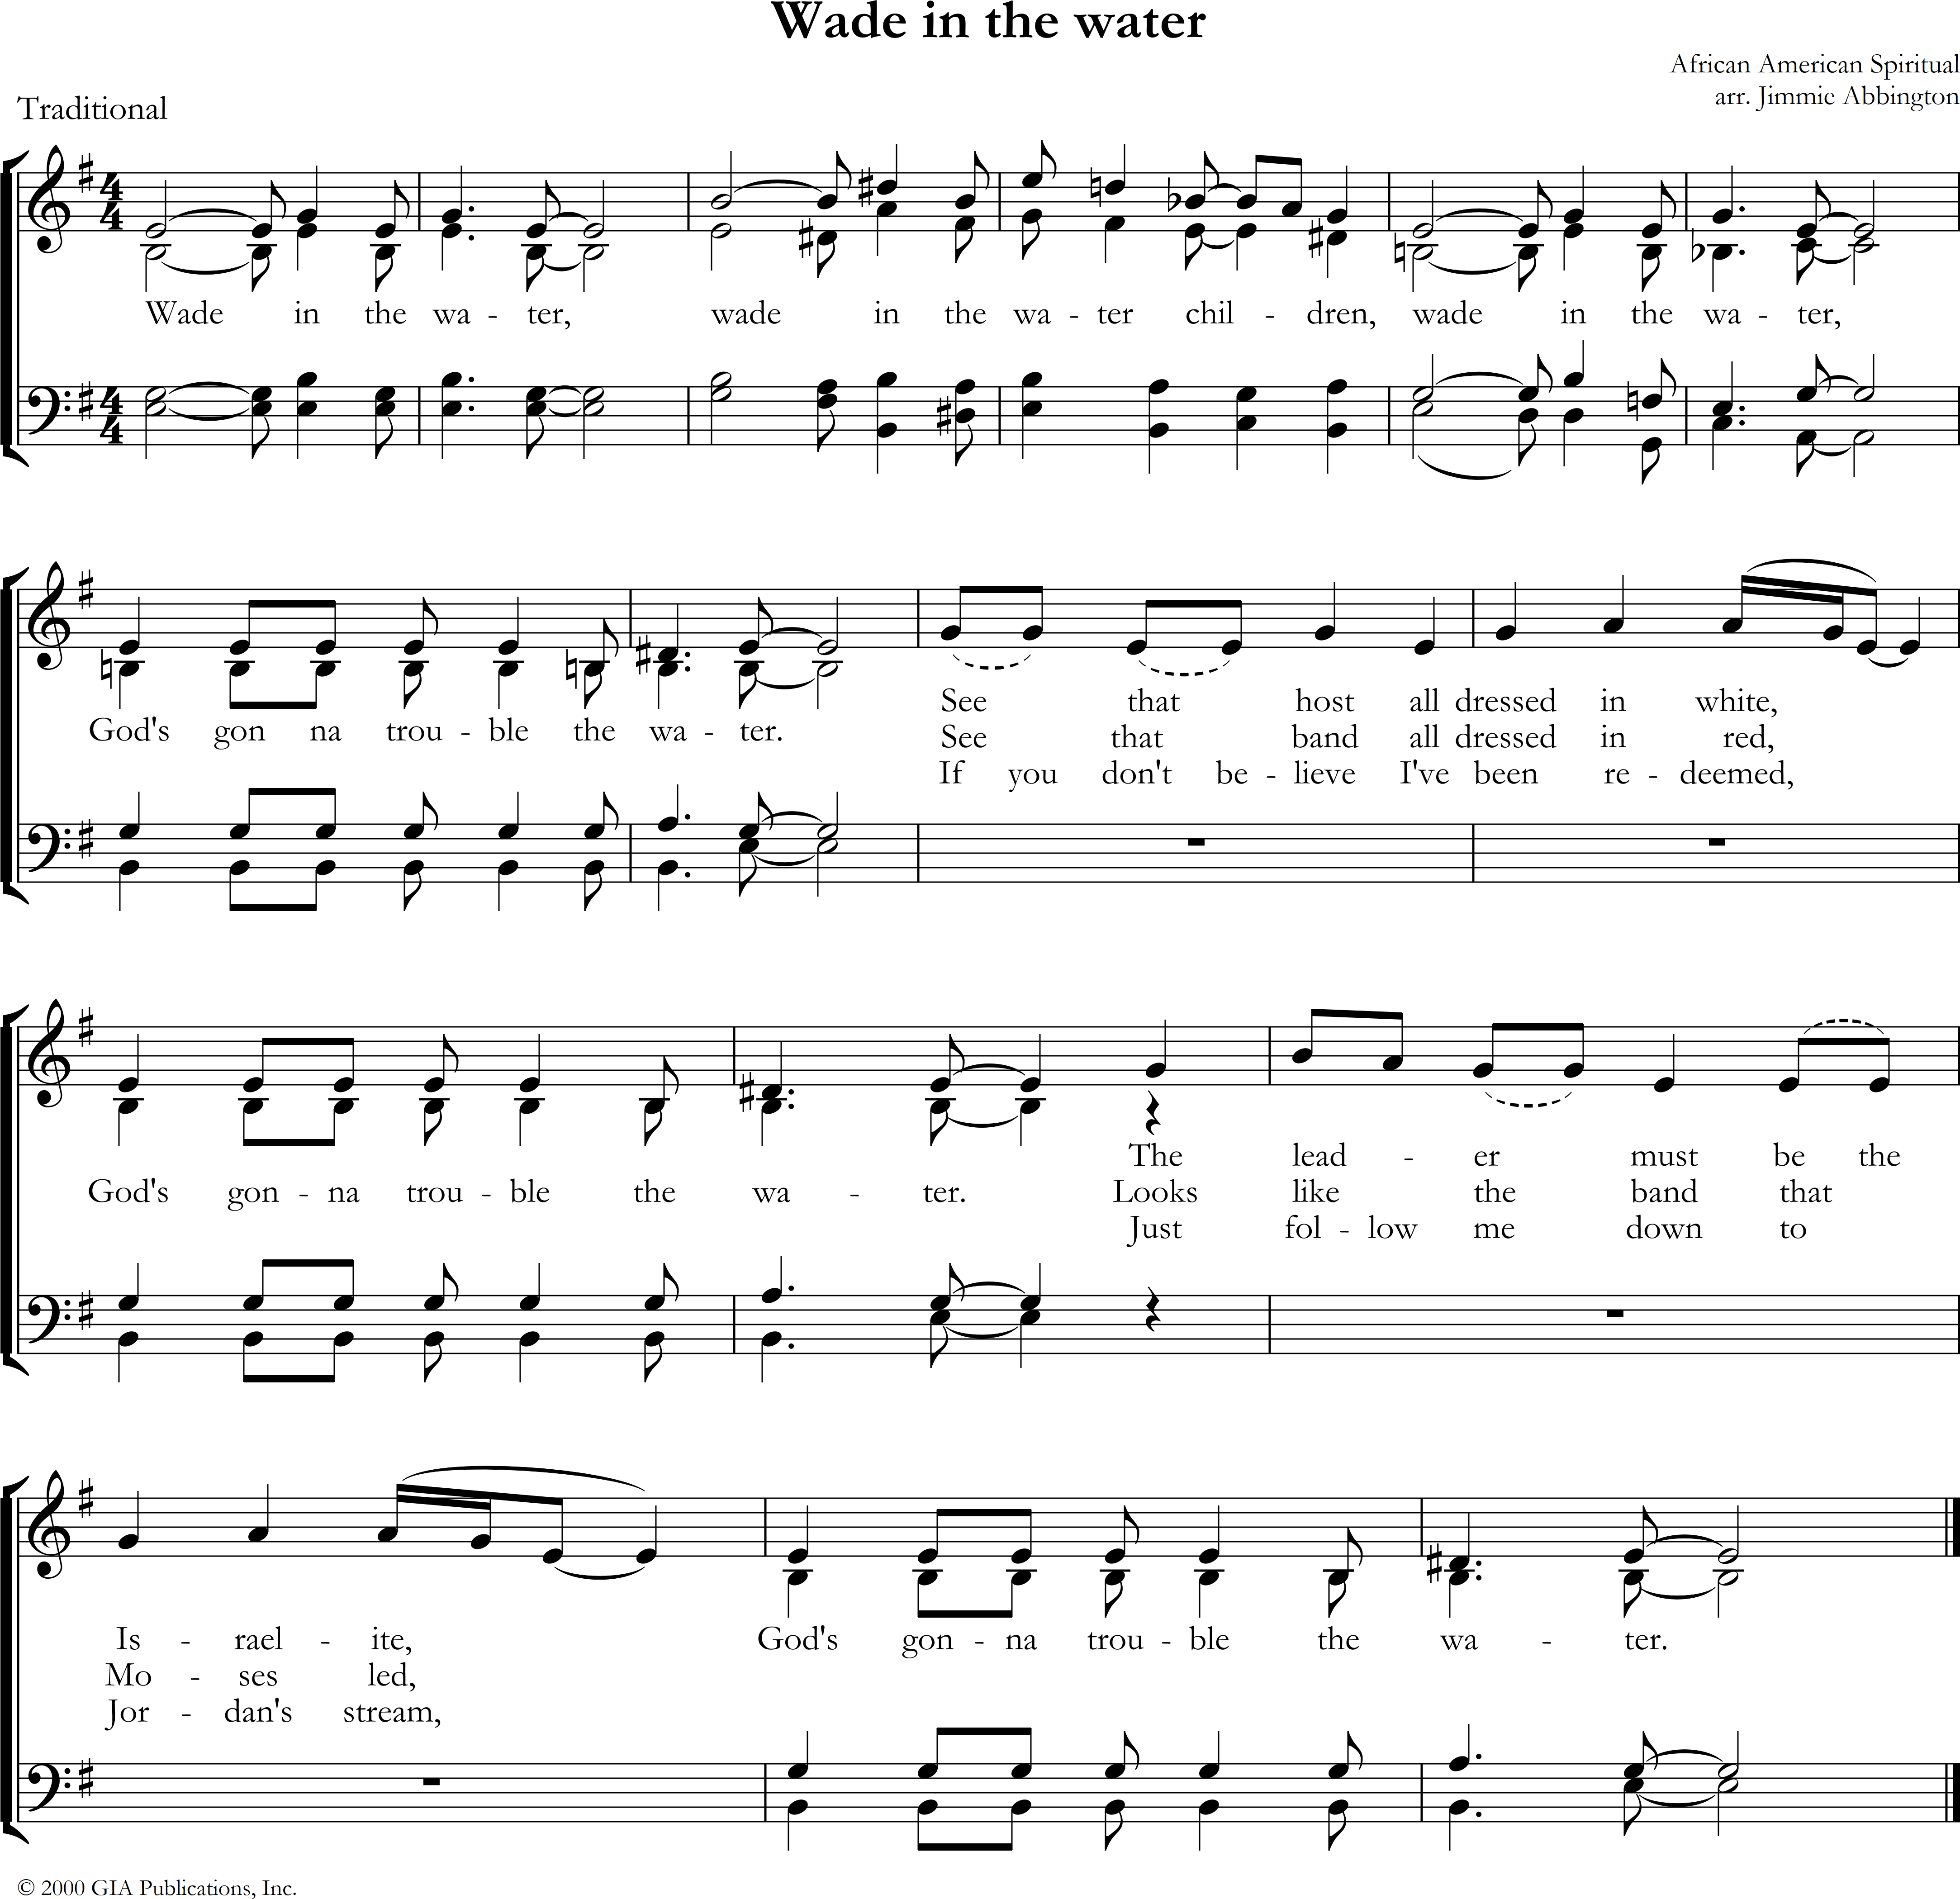

Hymn Come thou fount of every blessing

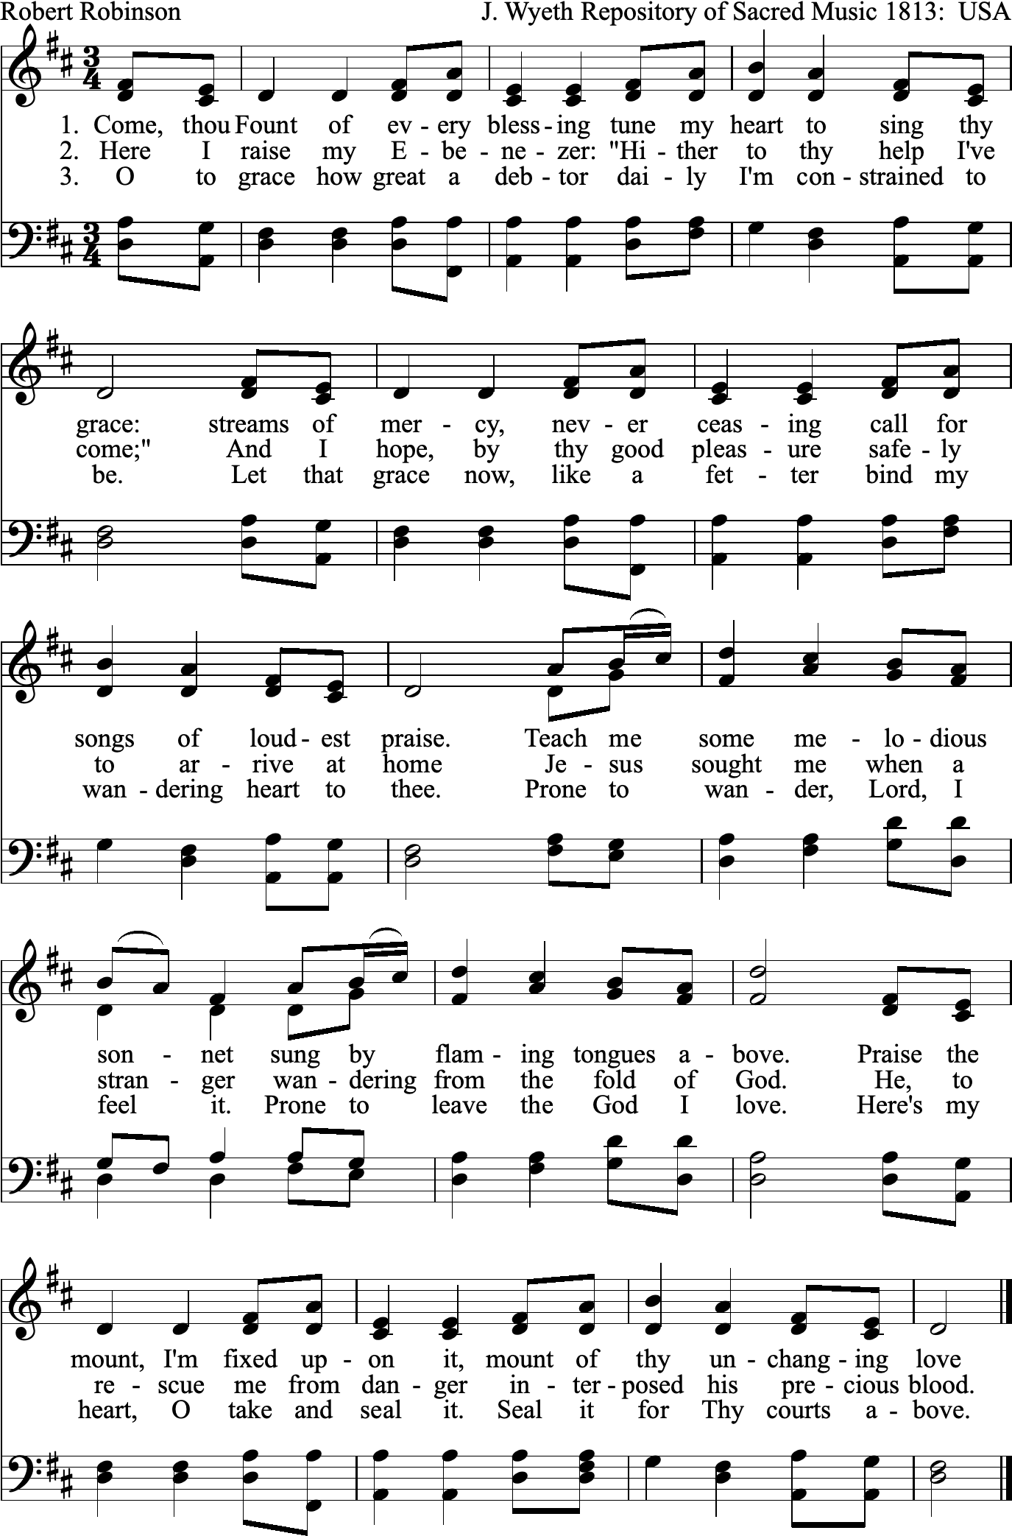

Hymn What a fellowship, what a joy divine

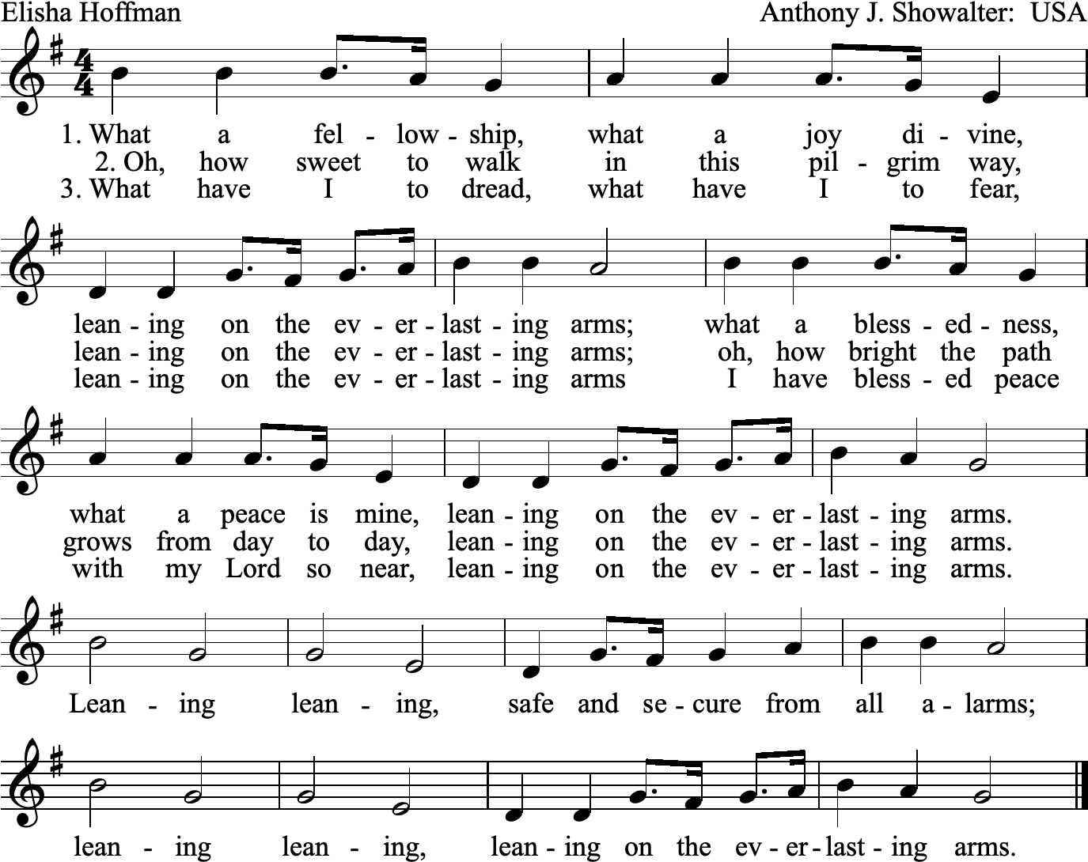

Closing Hymn Lift every voice and sing

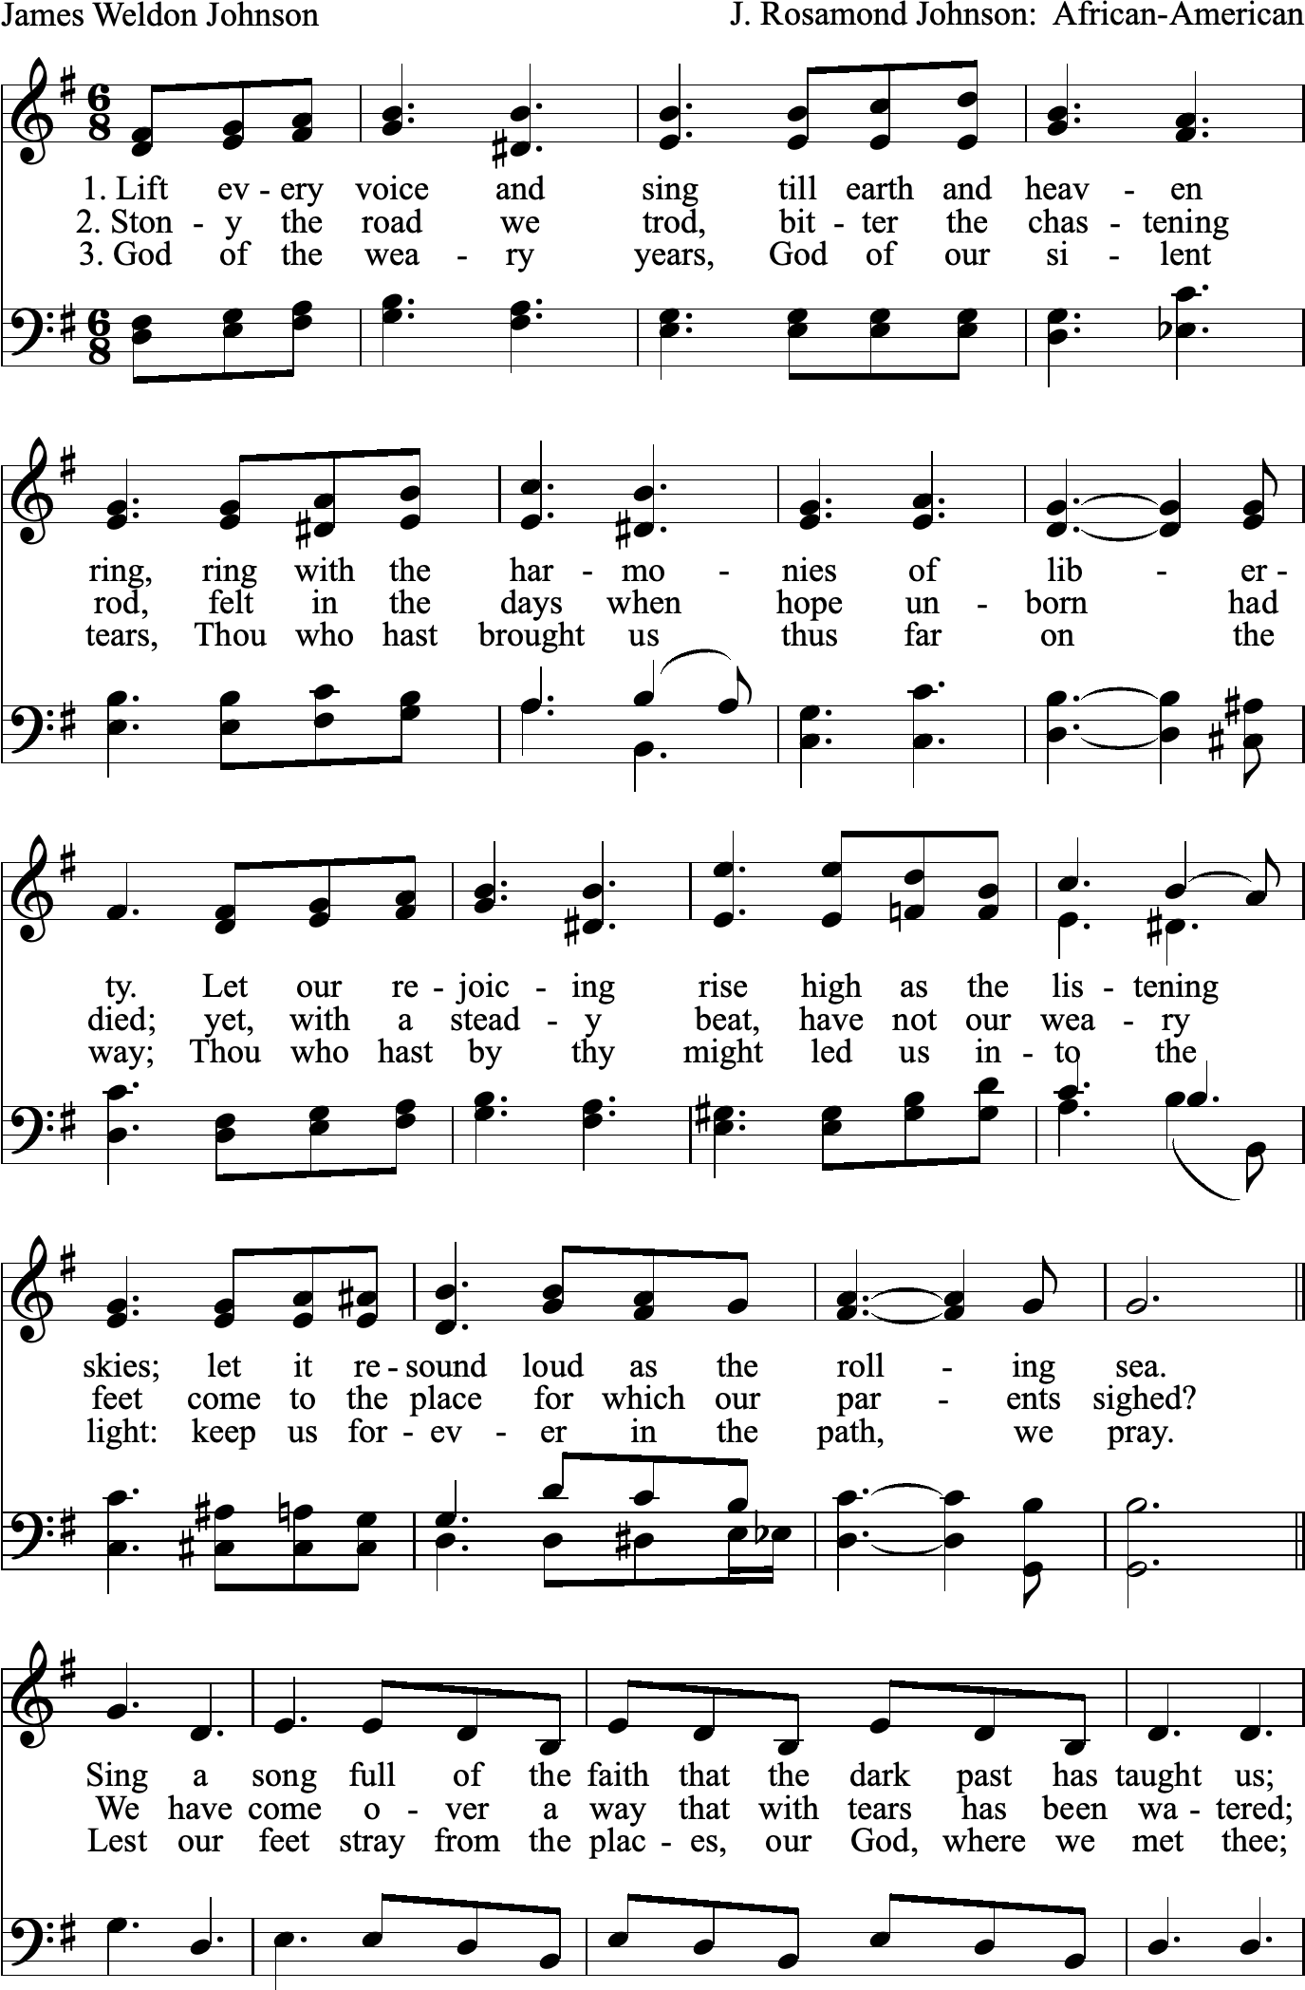

Revd Dr Martin Luther King Jr.
* These hymns have been suggested by the writing group from the Minnesota Council of Churches, which prepared the first project of the Week of Prayer for Christian Unity 2023, and are published under their responsibility.
This hymn was sung by thirty-eight Dakota prisoners of war as they were led to execution at Mankato, Minnesota, on December 26, 1862. This song was first published in the Dakota Indian Hymnal (1916) and is perhaps the only Native American hymn to be sung broadly in North America beyond its original Dakota culture. The author, Joseph Renville, was indigenous Dakota and the translator of this hymn is Francis Philip Frazier.
This is an African American Jubilee Spiritual by Frederick J. Work, John Wesley Work Jr. (1901), based upon the narrative of John 5:2-9. For the enslaved, this song represented the struggles of life and the empowerment of freedom. Within the context of the ‘troubled’ waters of life there are healing waters, because God is in the midst of the turmoil.
This hymn, authored in 1887 by E. A. Hoffman, was inspired by Deuteronomy 33:27. It is meant to help contemplate what it means to find refuge in our heavenly Father's arms in times of fear and trial, and to allow God’s joy and peace to replace our loneliness and anxiety.
This is an African American Jubilee Spiritual which was written by James Weldon Johnson (1900). It is often referred to as the Black national anthem in the United States. The song is a prayer of thanksgiving for faithfulness and freedom for the enslaved voicing a cry for liberation and affirmation for African American people.

